# From the docking study, Epigallocatechin gallate (PDB Id- 65064) and Quercetin (PDB Id- 5280343) has the highest binding affinity compared to other compounds and the standard. They both produced nine (9) poses while the standard has one (1) pose. Visualization study showed compound 65064 to have best interaction. unfavorable acceptor-acceptor interaction exist on 5280343 and the standard compound also has unfavorable bump………………………..

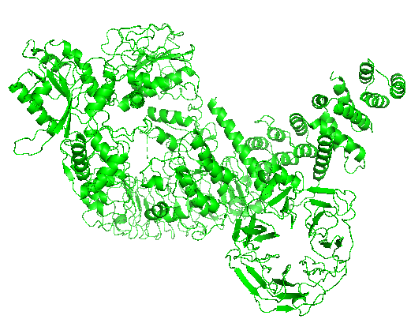

Fig 1: 3D structure of target protein (mutant LRRK2)

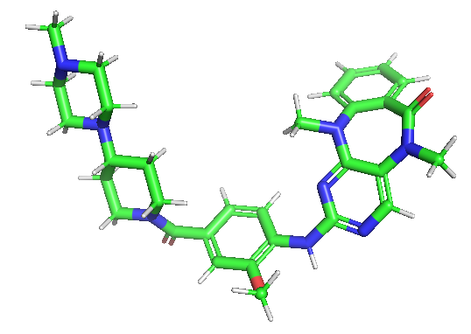

Fig 2: 3D structure of the standard compound (Lrrk2-IN-1)

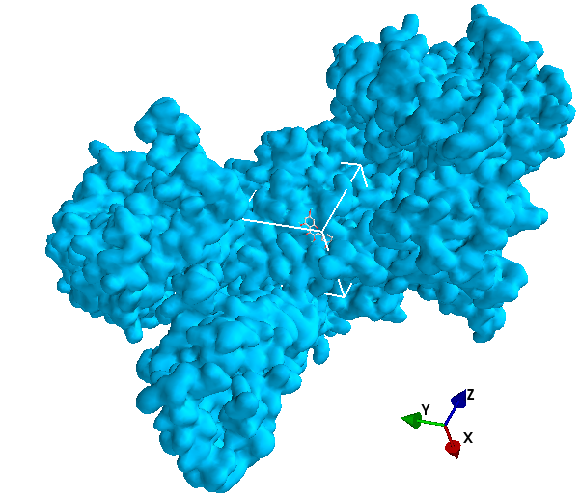

Fig 3: 3D structure of hit ligand 5280343 at target protein binding site

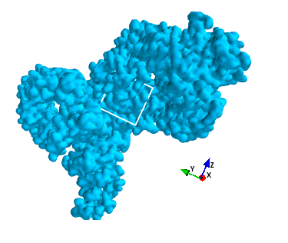

Fig 4: 3D structure of hit ligands and standard at target protein binding site

Table 1: Result of the docking study of the standard and the test ligand against the target protein respectively with nine poses for each.

|  |  |
| --- | --- |
| Ligand | Binding Affinity |
| 5280343 | -6.9 |
| 5280343 | -6.2 |
| 5280343 | -5.8 |
| 5280343 | -5.6 |
| 5280343 | -5.6 |
| 5280343 | -5.5 |
| 5280343 | -5.5 |
| 5280343 | -5.5 |
| 5280343 | -5.5 |
| 65064 | -7.4 |
| 65064 | -7.3 |
| 65064 | -6.7 |
| 65064 | -6.2 |
| 65064 | -6.2 |
| 65064 | -6.2 |
| 65064 | -6.1 |
| 65064 | -6 |
| 65064 | -5.9 |
| 46843906 | 4.5 |

**Note:** 65064 is the PubChem ID of the compound Epigallocatechin gallate

# 5280343 is the PubChem ID of the compound Quercetin

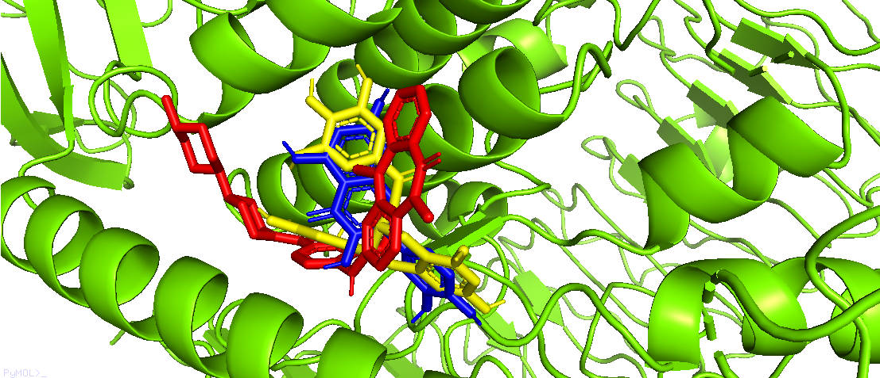

Fig 5: The hit ligands and standard at the binding site of target protein

Key: Yellow: 65064

Blue: 5280343

Red: 46843906

Green: Target protein

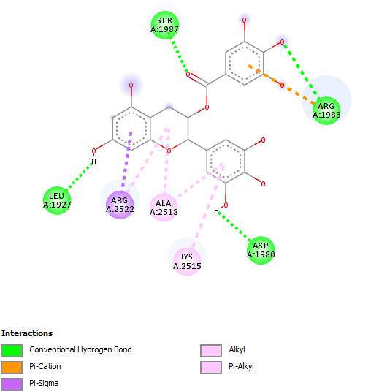

Fig 6:2D structure of hit ligand 65064 and target protein complex

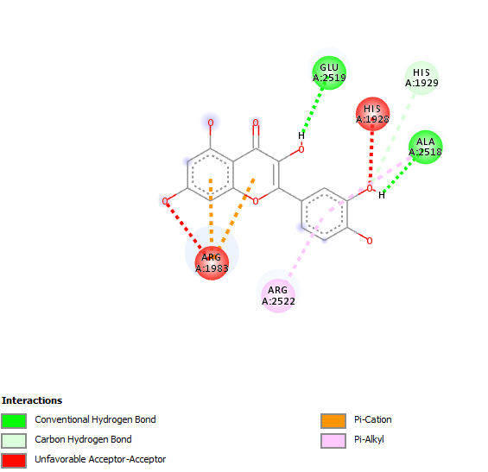

Fig 7: 2D structure of hit ligand 5280343 and target protein complex

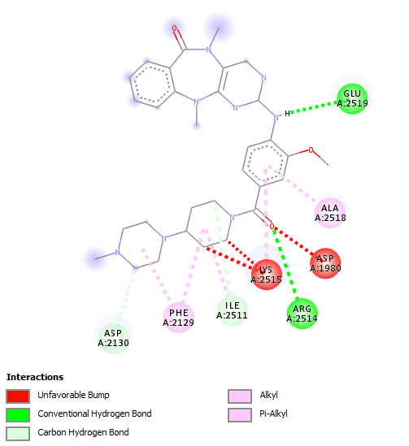

Fig 8: 2D structure of hit ligand standard and target protein complex